M365 Admin Agent in M365 Copilot Home Page
Created Tuesday, May 12, 2026

Table of Contents
1 Overview 1
1.1 Sample Prompts 1
1.2 Home URL – Screen Shot 2
1.3 M365 Admin Agent is clicked (left, built-in) – Screen Shot 3
2 Prompt Session 3
2.1 Prompts – initial – What Can You Help Me With? 3
2.2 Prompt: Help Assigning Admin Roles 5
2.3 Prompt: Check service health statuses 6
2.4 Prompt: Create a recurring health check schedule for critical services? 6
2.5 Schedule weekly summary reports of health checks to the IT leadership 7
2.6 Find groups without an owner 9

Overview
Top
Seen at M365 Copilot home page as built-in A.I. Agent (conversational, not automated)
This on the M365 E5 Commercial Developer Program – which is free for developers.
This shows what Admin Centers such as M365 Admin Center – will have for the future:
Natural language queries and prompts for information and diagnosis of problems plus issues like wrong settings.
Microsoft 365 Admin | M365 Copilot
https://m365.cloud.microsoft/chat/agent/P_c0fd1ab0-cbf3-7eb9-1a7d-2d823549ef31.8ad61c39-5b6e-447c-b26a-a64eee436502?fromcode=cmmqidzluiz&from=NoAccountOnStart

Sample Prompts

- Enable daily health checks for critical services and notify on-call when issues are detected
- Schedule weekly summary reports of health checks to the IT leadership
- Would you like me to tailor the checks to include all tenants or only the MyDomain domain?

What can you help me with?

Microsoft 365 Admin said:

Microsoft 365 Admin
Thanks for asking! I can help IT admins understand how people in their organizations are using Microsoft 365, and guide them in managing access. Here's an overview of how I can help:
Show you relevant news from the Microsoft 365 admin center
Try asking: Recap info from the admin center or Check service health statuses
Identify users and groups that might need your oversight
Try asking: Find groups without an owner or find users who don't have a license
Help you unblock your users
Try asking: Find users who can't sign in or Where do I reset user passwords?
Provide info and insights about licensing
Try asking: How many available licenses do I have?
Tell you how and where to do admin tasks
Try asking: How do I set up branded business email? or Where do I assign admin roles?
There's a lot more I can do, too. Look for the View prompts button near the text box for ideas.

Home URL – Screen Shot
https://m365.cloud.microsoft
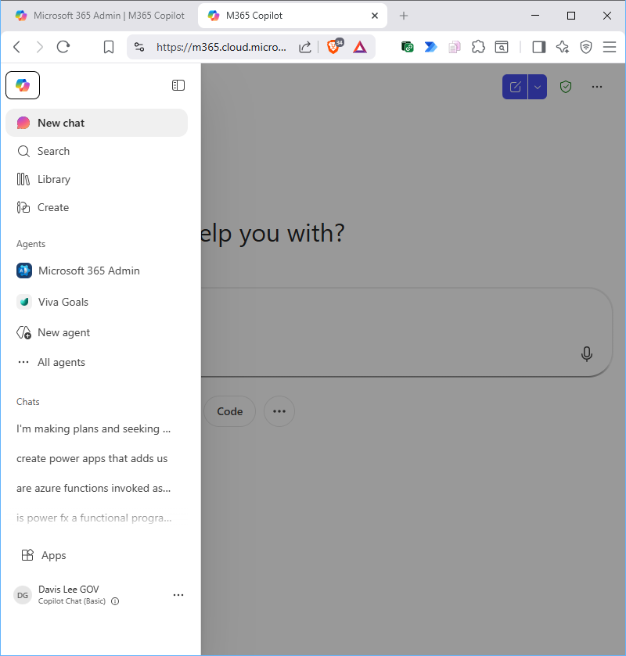

M365 Admin Agent is clicked (left, built-in) – Screen Shot
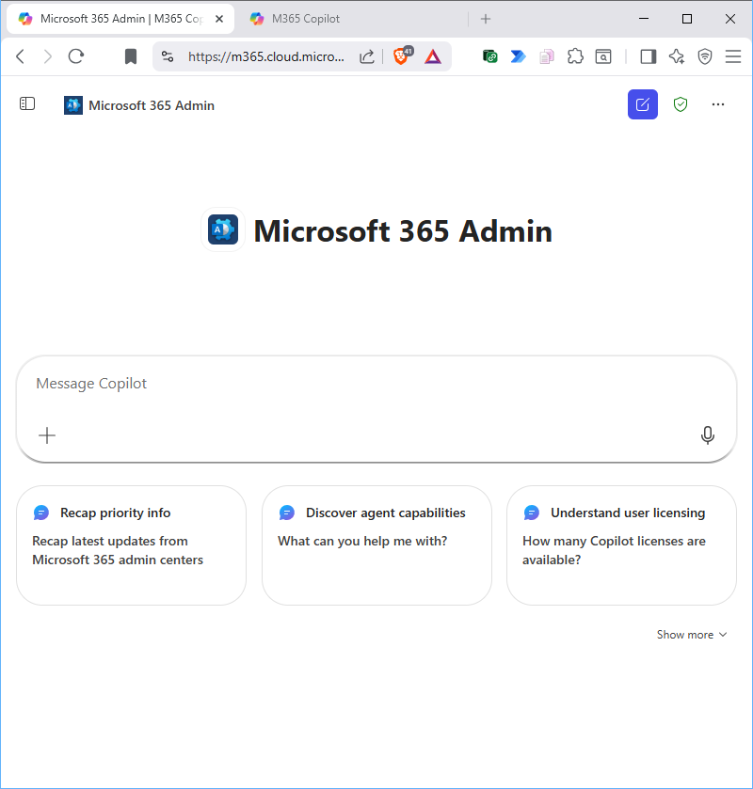

Prompt Session
Top

Prompts – initial – What Can You Help Me With?
Tuesday, May 12, 2026
What can you help me with?

Thanks for asking! I can help IT admins understand how people in their organizations are using Microsoft 365, and guide them in managing access. Here's an overview of how I can help:
Show you relevant news from the Microsoft 365 admin center
Try asking: Recap info from the admin center or Check service health statuses
Identify users and groups that might need your oversight
Try asking: Find groups without an owner or find users who don't have a license
Help you unblock your users
Try asking: Find users who can't sign in or Where do I reset user passwords?
Provide info and insights about licensing
Try asking: How many available licenses do I have?
Tell you how and where to do admin tasks
Try asking: How do I set up branded business email? or Where do I assign admin roles?
There's a lot more I can do, too. Look for the View prompts button near the text box for ideas.
Where do I assign admin roles?
Here's how to assign admin roles in Microsoft 365:
🔒 Access the Admin Center
Sign in to the Microsoft 365 admin center, then navigate to Users > Active users. Go to the Microsoft 365 admin center. [Assign adm...min center]
📑 Step-by-step: assign a role
- Select the User whose admin role you want to change.
- In the flyout pane, under Roles, select Manage roles.
- Choose the administrator role you want to assign. If you don't see the role, select Show all at the bottom of the list.
🧩 Multiple users with PowerShell
- You can also assign roles to multiple users using PowerShell if needed.
✅ Verify roles
- To check assigned roles, review the user's details under Roles or use the Roles section to see which users are assigned to each role.

Prompt: Find groups without an owner
Find groups without an owner or find users who don't have a license

I found multiple matching users across the searches and I’m ready to export the results. Here are the findings from each step with the most useful fields surfaced.
📑 Step 1: 23 users found (broad criteria)
Name | Email
Adele Vance | AdeleV@MyDomain.onmicrosoft.com
Alex Wilber | AlexW@MyDomain.onmicrosoft.com
Billiam User1 | BillUser1@MyDomain.onmicrosoft.com
Bookings July 2023 | BookingsJuly2023@MyDomain.onmicrosoft.com
Darren Wall | DarrenWall@MyDomain.onmicrosoft.com
Darren2 Wall | DarrenWall2@MyDomain.onmicrosoft.com
Davis Lee (Treasury) | DavisLeeTreasury@MyDomain.onmicrosoft.com
Davis Lee GOV | MyDomain@MyDomain.onmicrosoft.com
Diego Siciliani | DiegoS@MyDomain.onmicrosoft.com
Grady Archie | GradyA@MyDomain.onmicrosoft.com
Henrietta Mueller | HenriettaM@MyDomain.onmicrosoft.com
Isaiah Langer | IsaiahL@MyDomain.onmicrosoft.com
Johanna Lorenz | JohannaL@MyDomain.onmicrosoft.com
Joni Sherman | JoniS@MyDomain.onmicrosoft.com
Lee Gu | LeeG@MyDomain.onmicrosoft.com
Lidia Holloway | LidiaH@MyDomain.onmicrosoft.com
Lynne Robbins | LynneR@MyDomain.onmicrosoft.com
Megan Bowen | MeganB@MyDomain.onmicrosoft.com
Miriam Graham | MiriamG@MyDomain.onmicrosoft.com
Nestor Wilke | NestorW@MyDomain.onmicrosoft.com
Patti Fernandez | PattiF@MyDomain.onmicrosoft.com
Pradeep Gupta | PradeepG@MyDomain.onmicrosoft.com
Sueanne User2 | SueUser2@MyDomain.onmicrosoft.com

📑 Step 2: 22 filtered users (two-criteria match)
Name | Email
Adele Vance | AdeleV@MyDomain.onmicrosoft.com
Alex Wilber | AlexW@MyDomain.onmicrosoft.com
Billiam User1 | BillUser1@MyDomain.onmicrosoft.com
Darren Wall | DarrenWall@MyDomain.onmicrosoft.com
Darren2 Wall | DarrenWall2@MyDomain.onmicrosoft.com
Davis Lee (Treasury) | DavisLeeTreasury@MyDomain.onmicrosoft.com
Davis Lee GOV | MyDomain@MyDomain.onmicrosoft.com
Diego Siciliani | DiegoS@MyDomain.onmicrosoft.com
Grady Archie | GradyA@MyDomain.onmicrosoft.com
Henrietta Mueller | HenriettaM@MyDomain.onmicrosoft.com
Isaiah Langer | IsaiahL@MyDomain.onmicrosoft.com
Johanna Lorenz | JohannaL@MyDomain.onmicrosoft.com
Joni Sherman | JoniS@MyDomain.onmicrosoft.com
Lee Gu | LeeG@MyDomain.onmicrosoft.com
Lidia Holloway | LidiaH@MyDomain.onmicrosoft.com
Lynne Robbins | LynneR@MyDomain.onmicrosoft.com
Megan Bowen | MeganB@MyDomain.onmicrosoft.com
Miriam Graham | MiriamG@MyDomain.onmicrosoft.com
Nestor Wilke | NestorW@MyDomain.onmicrosoft.com
Patti Fernandez | PattiF@MyDomain.onmicrosoft.com
Pradeep Gupta | PradeepG@MyDomain.onmicrosoft.com
Sueanne User2 | SueUser2@MyDomain.onmicrosoft.com

📑 Step 3: 23 filtered users (two-criteria match)
Name | Email
Adele Vance | AdeleV@MyDomain.onmicrosoft.com
Alex Wilber | AlexW@MyDomain.onmicrosoft.com
Billiam User1 | BillUser1@MyDomain.onmicrosoft.com
Bookings July 2023 | BookingsJuly2023@MyDomain.onmicrosoft.com
Darren Wall | DarrenWall@MyDomain.onmicrosoft.com
Darren2 Wall | DarrenWall2@MyDomain.onmicrosoft.com
Davis Lee (Treasury) | DavisLeeTreasury@MyDomain.onmicrosoft.com
Davis Lee GOV | MyDomain@MyDomain.onmicrosoft.com
Diego Siciliani | DiegoS@MyDomain.onmicrosoft.com
Grady Archie | GradyA@MyDomain.onmicrosoft.com
Henrietta Mueller | HenriettaM@MyDomain.onmicrosoft.com
Isaiah Langer | IsaiahL@MyDomain.onmicrosoft.com
Johanna Lorenz | JohannaL@MyDomain.onmicrosoft.com
Joni Sherman | JoniS@MyDomain.onmicrosoft.com
Lee Gu | LeeG@MyDomain.onmicrosoft.com
Lidia Holloway | LidiaH@MyDomain.onmicrosoft.com
Lynne Robbins | LynneR@MyDomain.onmicrosoft.com
Megan Bowen | MeganB@MyDomain.onmicrosoft.com
Miriam Graham | MiriamG@MyDomain.onmicrosoft.com
Nestor Wilke | NestorW@MyDomain.onmicrosoft.com
Patti Fernandez | PattiF@MyDomain.onmicrosoft.com
Pradeep Gupta | PradeepG@MyDomain.onmicrosoft.com
Sueanne User2 | SueUser2@MyDomain.onmicrosoft.com

📑 Step 4: 1 filtered user (narrowed to a single match)
Name | Email
Bookings July 2023 | BookingsJuly2023@MyDomain.onmicrosoft.com

If you'd like, I can export these results to CSV now or format them for Excel. You can also export all steps together as a single consolidated file if helpful.
- Show in Active users
- Export to CSV

Would you like me to export these four search results to CSV or Excel now?

Prompt: Help Assigning Admin Roles
Would you like help assigning admin roles to multiple users at once?
Yes
I’ve surfaced the latest admin headlines for you and summarized their impact so you can act quickly.
📑 Service health
- Overview: I found 0 issues for your organization to act on, 1 active incident and 4 advisories related to your service health.
- Incidents: CW1300750 — Some users may be unable to access links to other apps provided by Microsoft 365 Copilot Chat prompts. View incident details
- Advisories: Exchange Online (2 advisories), Microsoft Viva (1 advisory), and 1 additional advisory.
Action: You can open Service Health to review all currently active items.
📬 Message center
- Overview: Out of 440 new update messages, 47 seem highly relevant to your organization.
- New feature updates: Microsoft Loop – Admin Usage Reports (MC929020, MC929022), OneDrive: Simplified file transfer for departing employees (MC1164381). 28 more unread updates.
- Feature updates: Updated UI for Copilot Chat entry point in Office apps (MC1189000), Chat visibility in Copilot App (MC1197289), Outlook Mobile DLP tips (MC1129716). 13 more updates.
Action: You can view in Message Center to drill into these items.
💬 Microsoft Teams meetings and calls
- Your tenant meets Microsoft’s recommended practices for Teams meetings and calls, and is well-optimized for a great meeting experience.
Action: No immediate action required unless you want to review meeting configuration in detail.

Would you like me to drill into any specific incident, advisory, or message center post now?

Prompt: Check service health statuses
Check service health statuses
I’ve checked service health statuses and I’m ready to share the latest results.
📊 Service Health Status
No final health data was returned in this session for presentation. If you’d like, I can re-run the health check to fetch the current incidents and maintenance windows across all services (Exchange, SharePoint, Teams, OneDrive, etc.).

Would you like me to set up automatic health alerts for specific services (e.g., Exchange, SharePoint, Teams)?

Prompt: Create a recurring health check schedule for critical services?
Create a recurring health check schedule for critical services?
I’ve outlined a practical recurring health check plan for your critical services. Here’s a concise proposal you can implement or adjust as needed.
📑 Proposed Health Check Schedule
- Frequency: Daily health checks for real-time issue detection; weekly summary reports for leadership visibility.
- Timing: Daily checks at 02:00 local time (off-peak) with a broader weekly window for the summary on Mondays at 08:00.
- Scope (critical services): Core infrastructure (identity, authentication, networking), key apps, and any service with a known history of incidents.
- Output: Automated status results (pass/fail), incident counts, and any degraded components.
- Recipients: On-call engineer for daily alerts; IT leadership for weekly summaries.
🔔 Notification & Escalation Details
- Alerts: Immediate notifications when a check detects a failure or degraded state.
- Escalation chain: On-call → Team lead → IT leadership if issues persist > X minutes/hours.
- Response SLAs: Acknowledge within 15 minutes; initial triage within 30 minutes; remediation plan within 2 hours for critical services.
🧭 How to implement (high level)
- Define the exact list of “critical services” in your environment.
- Set up automated checks (availability, latency, error rates, dependency health).
- Configure alerting rules and escalation paths in your monitoring tool or IT service management platform.
- Create a recurring task to generate and distribute the weekly leadership summary.

Do you want me to tailor this to include all tenants or only the MyTest domain?
Would you like me to show how to configure the daily checks and weekly summaries in your monitoring/ITSM tool, step by step?
Would you like me to add a quarterly review milestone to reassess the critical services list and the check coverage?

Prompt: Schedule weekly summary reports of health checks to the IT leadership
Schedule weekly summary reports of health checks to the IT leadership

I can set up a recurring weekly health-check summary for IT leadership, but the latest data pull returned no health-check items to include in the report yet.
📑 Health Check Snapshot
There were no health-check items returned in the most recent run. If you’re expecting data, we can re-run or broaden the scope to ensure the summary has content.
🔧 How to schedule a weekly health-check summary
- Use Power Automate to create a new flow with a weekly recurrence trigger (for example, every Monday at 9:00 AM).
- Add steps to fetch your health metrics from your monitoring source (e.g., service status, uptime, incident counts, backup status).
- Assemble a concise summary in the email body, including key KPIs, notable incidents, and any exceptions requiring attention.
- Send the summary to the IT leadership distribution list. Use a clear subject like: “Weekly Health Check Summary – [Date Range]”.
- (Optional) Attach a CSV/Excel with the raw metrics or post the report to a shared location (e.g., a SharePoint folder) for archival access.
If you’d like, I can draft the flow, pull in example health metrics, and wire up the email so it runs automatically each week. You’ll only need to confirm the data sources and recipients.

Would you like me to set up this weekly health-check report flow now for you?

yes set up this weekly health-check report flow now

Here's how to set up weekly health-check report notifications in Microsoft 365:
📑 Overview
Weekly health-check reports can be generated by email notifications from the Service Health Dashboard in the Microsoft 365 admin center. Admins can customize notifications to receive updates about service health incidents and advisories. [Microsoft...ice Health]
🔧 Configure notifications
Follow these steps to enable and tailor weekly health-check emails:
- Go to the Microsoft 365 admin center and sign in with your admin account.
- In the left-hand navigation, select Health > Service health or use the Service health card on the Home dashboard. [How to che...ice health]
- Select Customize > Email in the Service Health Dashboard.
- Check Send me email notifications about service health.
- Specify up to two email addresses and select the services and types of notifications (incidents or advisories) you want to receive.
- Each admin can set their own preferences; the limit of two email addresses is per admin account.
✅ Verification
These notifications will provide regular updates on service health, which can be used as weekly health-check reports.

Would you like me to configure this weekly health-check flow for you now?
configure this weekly health-check flow now

